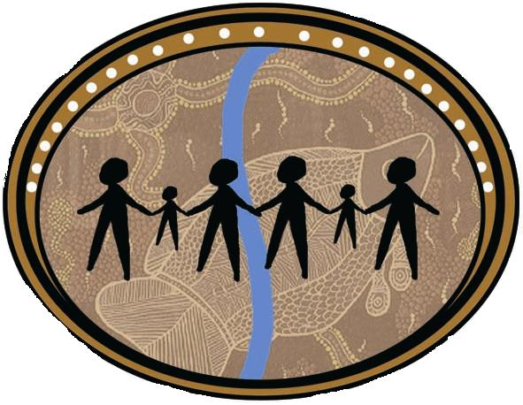 | Albury Wodonga Aboriginal Health Service Inc  ABN: 84286953178  Phone: (02) 6040 1200 Fax: (02) 6040 1222  Toll Free: 1800 421 640  664 Daniel Street Glenroy 2640  (PO Box 3040, Albury, NSW, 2640)  554 Stanley Street, Albury 2640  12 Stanley Street Wodonga, VIC, 3690

POSITION DESCRIPTION

Position Title: ITC Chronic Disease Outreach Worker

Reports To: Clinic Manager

Term of Employment: Full time position

Award : Aboriginal Community Controlled Health Services
Award

Salary: As per Contract.

This is an identified Aboriginal/Torres Strait Islander Position

Position Approval  Updated: 5/6/2022 | Approved: David Noonan  Date: 6/6/2022

ORGANISATION
Albury Wodonga Aboriginal Health Service Inc. (AWAHS) is an Aboriginal Community Controlled Health Organisation. AWAHS provides first class Primary Health Care Services, Allied Health and Dental Services to the Aboriginal community who reside in Albury / Wodonga and surrounding areas. As a Bulk Billing Health Service there is no charge to our clients for the medical services provided.

AWAHS is funded with the Murray Integrated Team Care (ITC) program, with a chronic disease outreach worker (CDOW) supported in this program.

VISION STATEMENT
To provide comprehensive quality health and family services based on respect for Aboriginal Culture.

POSITION PURPOSE
The role of the CDOW is to assist in reducing chronic disease morbidity and mortality through investment in preventative social marketing activities, expansion of the Indigenous health sector and building the capacity for health care services to deliver effective services to manage chronic disease for Aboriginal and Torres Strait Islander people.

The CDOW will work closely with the Integrated Team Care (ITC), Care Coordinator as the role of the Care coordinator is to direct the work flow to the CDOW. The CDOW will also work as part of the overall ITC team and service providers and networks to build capacity to offer Aboriginal and Tores Strait Islander patient services in the local community. The position will also work to support services to improve transition between components of the service system for the Aboriginal and Tores Strait Islander community.

RELATIONSHIPS
Supervision
The position reports directly to the Clinic Manager of AWAHS

Internal
The CDOW will work collaboratively with all other team members of AWAHS.

External
The CDOW will be expected to liaise with key stakeholders who are involved in providing family based services to the local community as well as to the Aboriginal community.

DUTIES OF THE POSITION
Community Development/Health Promotion
- Participate in, promote and develop projects and programs that enhance the community’s understanding of health issues.
- Raise awareness of Aboriginal health issues and advocate for best practice approaches amongst agencies.
- Provide community education, awareness and prevention programs in health.
- Work with the community to develop and implement a range of activities to promote better health for the community.
- Work collaboratively with other service providers to develop and implement cultural understanding within health staff’s work practices.
- Up skill new Medical, Nursing, Allied Health staff and students, with current & relevant health knowledge.
- Provide support to community regarding Quit smoking brief intervention.

Administrative
- Maintain accurate client and program records and statistics as required.
- Actively uphold the AWAHS philosophy, policies and procedures.
- Participate in the ongoing development and implementation of policies which are sensitive to the identified health needs and concerns of Aboriginal people/communities and which reflect the principles of social justice and equity, by consultation, participation and advocacy in appropriate forums.
- Maintain confidentiality.
- Contribute to the development and maintenance of a supportive environment within the team.
- Participate in the evaluation of the program's services and group activities.
- Work in accordance with the EEO, WH&S, Code of Conduct and safe working practices, policies and procedures of the Albury Wodonga Aboriginal Health Service.
- Monthly workers report (including relevant KPI’s met).

Professional
- Accept personal responsibility and be accountable for professional practice.
- Participate in performance appraisal and supervision processes.
- Maintain professional skills and knowledge via appropriate staff development activities.
- Demonstrate excellent communication skills in recording and reporting information to the multidisciplinary team.
- Participate in quality improvement activities.
- Work as part of a team and actively participate in staff meetings.
- Participate in research activities including the compilation of daily and monthly statistics on the services provided as required.
- Work within the scope of practice outlined.
- Work within the clinical guidelines, policies and procedures of AWAHS.
- Follow all WHS policies and procedures associated with conducting clinical activities within the client’s home (eg use of PPE).

Outreach
- to engage and build trusting relationships with Aboriginal families.
- to encourage and assist people to make contact with primary health care services.
- to escort people to and from appointments and assisting in the interpretation of instructions from a variety of medical services.
- Follow up patients to encourage them to return to the primary health care service for follow up appointments.
- Providing clinical services to patients appropriate to qualifications
- Providing information to people about how to access available services, particularly in relation to chronic disease (i.e. tobacco programs, health and wellbeing programs).
- to establish linkages and partnerships with relevant services
- to work cooperatively and support other team members in their duties;

SELECTION CRITERIA
Applications for this position will be considered initially on the basis of each applicant’s response to the following Essential Criteria. These criteria have been chosen as those reflecting the essential core requirements for appointment to the position.

Essential
- Certificate III or higher in Aboriginal and/or Torres Strait Islander Primary Health Care.
- Experience relevant to the role and working in a multidisciplinary team environment.
- Understanding of the health issues impacting Aboriginal and Torres Strait Islander communities
- Demonstrate knowledge in the principles of primary health.
- Proven high level of written, verbal and interpersonal communication skills.
- Excellent computer literacy.
- Current drivers’ licence.
- Demonstrated ability to negotiate with internal and external partners to achieve successful program implementation and sustainability.
- Eligible for Medicare provider number registration.

EMPLOYMENT PREREQUISITES
- Current and clear Criminal Record Check
- Current and clear Working with Children Check
- Complete and appropriate for role Health Declaration
- Completed Covid-19 vaccine status
- This is an identified Aboriginal/Torres Strait Islander Position. Proof of Aboriginality is a legitimate requirement. Exemption is claimed under Section 14 of the Antidiscrimination Act.

DECLARATION
I acknowledge that I have read the Position Description understood its contents and agree to work in accordance with the requirements of the position. I also understand and accept that I must comply with the organisation’s policies and procedures including Confidentiality and Code of Ethics during and beyond my employment with Albury Wodonga Aboriginal Health Service Ltd.

Name ……………………………………………………………………………………

Signature …………………………….. Date ……………………………

